New Journal at the Institute for Near Eastern Studies, University of Vienna
KESHIF e-Journal for Ottoman-Turkish Micro Editions
https://journals.univie.ac.at/index.php/keshif
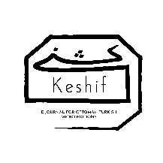
Keshif is a peer-reviewed online journal dedicated to collecting and editing short, interesting Ottoman texts and providing easy, free access to the material through a database with good search functions.
Here you find the Journal’s Mission Statement: https://journals.univie.ac.at/index.php/keshif/about
Keshif is released twice a year with a summer and a winter issue. The first issue will appear in the first months of 2023. The deadline for submitting articles is December 5, 2022.
Keshif wants to devote itself specifically to those texts that often come to light by chance during work with manuscripts: Isolated poems, letters, contracts, marginal notes of various contents, which are too “marginal” to be published on their own and at the same time too interesting to be forgotten. We treat these texts like little stones, perhaps even only splinters, which, over the years, could develop into a beautiful mosaic.

